EyeBallin’ Implementation Plan

Team Bob’s Bullies

**Submitted By:**

Kenzo Banaag, Tim Borisenko, Dane Erosa, Rebecca Rothschild, Isaac Schultz

**Instructor**: Dr. Bolong Zeng

**Date of Report Submission**: October 13th, 2019

**CPTS 484**

School of Electrical Engineering and Computer Science

Washington State University



# **Table of Contents**

**Table of Contents** **1**

**1 Introduction** **2**

1.1 Project Overview 2

The main features of this application will include: 2

1.2 Project Deliverables 2

**2 Project Organization** **2**

2.1 Process model 2

2.2 Organizational structure 3

2.3 Project responsibilities 3

**3 Managerial Process** **3**

3.1 Management objectives and priorities 3

3.2 Assumptions, dependencies, and constraints 3

3.3 Risk management 4

Perceived Risks (in order) 4

Risk management plan in respective order 4

Monitor risks 4

Communicate risk status throughout project. 4

3.4 Monitoring and controlling mechanisms 4

Keeping stakeholders informed 4

Assessing progress related to scope 4

Change requests 5

Updates to project documents 5

**4 Technical Process** **5**

4.1 Methods, tools, and techniques 5

4.1.1 Tools 5

4.2 Software documentation 6

4.2.1 UML Diagrams 6

Figure 4.2.1.1 Activity Diagram for EyeBallin System 7

4.3 Project support functions 8

**5 Work elements and schedule** **8**

# 

# **1 Introduction**

## 1.1 Project Overview

The project preliminary plan outlines the details for EyeBallin, an Android application for the visually impared that helps users navigate inside the Washington State University Everett campus.

### The main features of this application will include:

1. Verbal two way communication with the application
2. Safely navigate to a user specified location
3. Notify a user specified emergency contact if application detects user has fallen

## 1.2 Project Deliverables

The MVP is an application that helps the visually impaired navigate the WSU Everett campus.

1. Project Phase 1: Preliminary Project Plan, 9/08/19
2. Project Phase 1: Checkup Meeting
3. Project Phase 1: Project Submission/Presentation, 10/13/19
   1. WRS document
   2. Revised Phase I plan based on your preliminary plan.
   3. A collection of your meeting records. This could be one single document, a zip package of documents, or a link to your google doc/drive address, etc.
   4. PowerPoint slides you use for your presentation.
4. Project Phase 2: Checkup Meeting
5. Project Phase 2: Final Submission

Success criteria includes navigating to a destination within the WSU Everett building without looking at the application.

# **2 Project Organization**

## 2.1 Process model

The implementation process will be based upon a prototyping model. This makes the most sense to the team since the assignment requires at least one prototype. There are several features that need to be implemented; this will help the application get iterated upon until all features are present.

## 2.2 Organizational structure

In order to coordinate all the requirements we have decided on a team lead to distribute and manage tasks for the entire group. A technical writer will take charge of proofreading the requirements document.

## 2.3 Project responsibilities

Ultimately the entire project team is responsible for the successful delivery of the product. Once development begins, tasks will be delegated to efficiently complete individual work items.

Team member assignments per deliverable according to expertise:

1. Project Plan – Entire Team

2. Requirements Specification – Entire Team

3. Analysis – TBD

4. Architecture Spec – Entire Team

5. Component/Object Specification – TBD

6. Source Code – Entire Team

7. Test Plan – TBD

8. Final Deliverable – Entire Team

# **3 Managerial Process**

## 3.1 Management objectives and priorities

Throughout the duration of this project, each team member will have a turn acting as the project manager. In this role, individuals will have the final say on decisions, mediate group activities, and conduct final reviews before project submissions. In the same way, there will be rotating Technical writers that are responsible for documenting and testing code. Individuals in this role will also be charged with recording user experiences with the application

## 3.2 Assumptions, dependencies, and constraints

The user is only visually impared. All other motor, cognitive and sense related capabilities are fully intact. The user participating is also expected to be using a white cane while using navigation functionality with the application. A visually abled third party is expected to perform the initial setup for the application including download it and open it for the user.

Perceived constraints include the indoor domain. The application as it stands will only be functional for indoor spaces. Furthermore, it will be preconfigured for only the WSU Everett Building. The navigation capabilities will only be as useful as the map data that is configured. If there are some details left out of the map, the chosen path may not be optimal or even correct.

## 3.3 Risk management

### Perceived Risks (in order)

1. Project requirements changing (Bolong has hinted at this)
2. Not being able to complete all the requirements
3. Time management- with so many projects this quarter it may be difficult to spend time on this one
4. Failure to monitor risks

### Risk management plan in respective order

1. Use the change control plan to deal with changes in requirements when they arise
2. Set attainable requirements for ourselves. If the team is falling behind after setting requirements and deadlines, communicate with the client and among the team to reevaluate.
3. Set more meetings for the group to devote more time to this project.
4. Use a trello board or some other software to monitor our risks and continually revise them

### Monitor risks

1. Create consistent status reports and include risk management issues within the team
2. Revise risk plans according to any major changes in project schedule
3. Review and reprioritize risks, eliminating those with lowest probability
4. Think of potentially new risks after changes to project schedule or scope

### Communicate risk status throughout project.

1. Inform relevant stakeholders of growing risks
2. Update the Perceived Risks list and reprioritize them.

## 3.4 Monitoring and controlling mechanisms

### Keeping stakeholders informed

1. Regular meetings with Bolong.
2. Regular group meetings twice a week to keep the group up to date on current progress.

### Assessing progress related to scope

1. Assess work items according to schedule during group meetings.
2. If items are not being completed by the expected completion time, reassess schedule.
3. If items are being completed ahead of schedule, discuss possibly expanding the scope.

### Change requests

1. How to measure the impact of a change on the project.
   * 1. What requirements does it affect?
     2. Will it require code refactoring?
     3. Will it change the demographic of the clients were aiming at?
   1. As a group, we decided to unanimously vote on changes that the team lead would enforce.

### Updates to project documents

1. Documents will have a version number produced by our Technical Writer.
   1. Starts at 0.1, incremental updates change the decimal point, full rewrites change the one’s place.
2. Track all project documents with version control in google docs.
3. Updated documents should be marked with current version number on the title page and added to the git repository documents folder.
4. The team will be notified of the change on discord.

# **4 Technical Process**

## 4.1 Methods, tools, and techniques

We will use Java and Javascript to program the application. The IDE we have chosen to work with is android studio. For testing purposes we will have a non blind person test the app functionality while blind-folded. The software process model we while be using is the prototyping model.

### 4.1.1 Tools

We are considering the use of Android Studio as our main development platform. Android Studio mainly uses Java and XAML which all of us are familiar with. We are looking into using Google Maps Indoor API to be integrated in Android Studio to allow indoor navigation and location mapping.

Android Studio will be used as the main IDE and project type for the application. It mainly uses Java and XAML which the team members are familiar with. At this point, the Google Maps Indoor API will be used to model the building and create and follow navigation routes.

## 4.2 Software documentation

### 4.2.1 UML Diagrams

UML diagrams will be used to present the system at a high level. Activity, Class diagrams, Data Flow Diagrams and Sequence diagrams will be useful in data presentation.

For now, it is assumed that the application will run on a single thread, but that could change in the future.

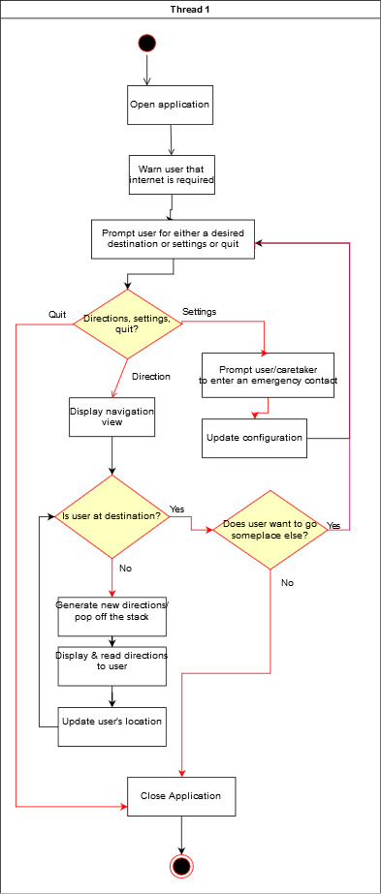

*Figure 4.2.1.1 Activity Diagram for EyeBallin System*

More diagrams will be developed as the implementation becomes more defined.

## 4.3 Project support functions

The team is planning on using Scrum with 2 week sprints throughout the duration of the project. If assistance is needed, we can seek help from Professor Zeng.

# **5 Work elements and schedule**

|  |  |  |  |
| --- | --- | --- | --- |
| Milestone | Team Members | Date Scheduled for Delivery | Date Delivered |
| Project Preliminary Plan | Dane Erosa  Isaac Shultz  Rebecca Rothschild  Tim Borisenko  Kenzo Banaag | 9/8 | 9/8 |
| Checkup Meeting | Dane Erosa  Isaac Shultz  Rebecca Rothschild  Tim Borisenko  Kenzo Banaag  Bolong Zeng | 9/20 | 9/20 |
| Project Phase 1: Final Submission | Dane Erosa  Isaac Shultz  Rebecca Rothschild  Tim Borisenko  Kenzo Banaag | 10/13 | 10/13 |
| Project Phase 1 Presentation | Dane Erosa  Isaac Shultz  Rebecca Rothschild  Tim Borisenko  Kenzo Banaag | 10/17 |  |
| Project Phase II: Checkup Meeting | Dane Erosa  Isaac Shultz  Rebecca Rothschild  Tim Borisenko  Kenzo Banaag  Bolong Zeng | 10/31 |  |
| Project Phase II: Final Submission | Dane Erosa  Isaac Shultz  Rebecca Rothschild  Tim Borisenko  Kenzo Banaag | 12/8 |  |